Original Paper

How to write your paper for iMedist (iMEDiTEC2021)

First A. Author ª, Second B. Author ^{b}, Third C. Author ^{b,*}

ª Centre for Sustainable Nanomaterials, Ibnu Sina Institute for Scientific and Industrial Research, Universiti Teknologi Malaysia, Skudai 81310, Johor, Malaysia
^{b} Department of Chemistry, Faculty of Science, Universiti Teknologi Malaysia, 81310 UTM Johor Bahru, Johor, Malaysia

* Corresponding author: author@xxx.xxx.xx

Article history  Received X XXX XXXX  Accepted XX XXX XXXX  Graphical abstract  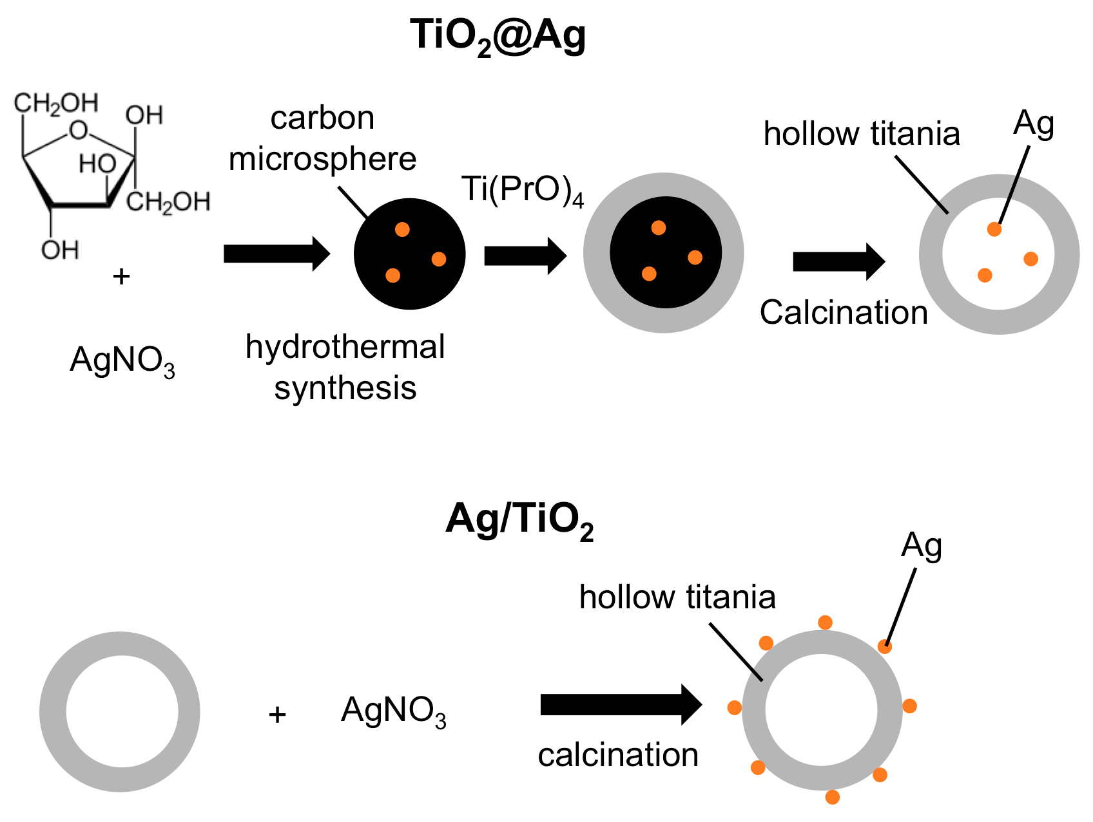 | Abstract  This document gives formatting instructions for authors preparing full paper in Microsoft Word to be submitted to this conference. The authors are asked to follow the instructions given in this document when preparing your full paper to assist the editors with the preparation of the manuscript to be published in the journal and to allow efficient reviewing of submissions by the reviewers and editors. You can use this document as both an instruction set and as a template into which you can type or paste your own text here.  Keywords: Keyword #1, keyword #2, keyword #3, keyword #3, keyword #4, keyword #5

INTRODUCTION

This document is a full paper template for Imedist 2021 joint conference. The submission of full paper should be made to respective conference website. An electronic copy of this template can be downloaded from the iMeditec2021 conference website https://www.utm.my/imeditec2021/submission

EXPERIMENTAL

Materials
The starting materials, fructose (D-(-)-type, Sigma­Aldrich, 99%), silver nitrate (AgNO₃, AR, QRëCTM), titanium tetraisopropoxide (TTIP, Sigma­Aldrich, 97%) and absolute ethanol (EtOH, HmbG® Chemicals) were used as the precursor for carbon microspheres, silver, and TiO₂ microspheres, respectively.

Synthesis of Ag/TiO₂ microspheres
The Ag/TiO₂ microspheres, where the location of Ag nanoparticles are attached on the external surface of hollow TiO₂, were prepared by deposition-precipitation method using urea and previously synthesized hollow anatase TiO₂. The synthesis of hollow TiO₂ spheres is given in details in reference (Baharvand et al., 2014). TiO₂ (0.1 g) was added to a 10 mL aqueous solution containing AgNO₃ (Ag 1 wt/wt %) and 0.25 g urea. The suspension was then refluxed at 80 °C and kept at this temperature for 4 h under continuous stirring. The sample was then collected by centrifugation, washed repeatedly with deionized water, dried for 12 h at 80 °C and then calcined at 300 °C for 4 h.

Synthesis of Ag@TiO₂ microspheres
The Ag@TiO₂ particles, silver loaded hollow anatase TiO₂ particles with the location of Ag are inside the hollow TiO₂ structure is by template method. 2.4 mL of aqueous solution AgNO₃ was added dropwise into 40 mL of aqueous fructose solution (0.5 M) under vigorous stirring. After stirring for 20 min, the solution was transferred and sealed in a Teflon-sealed autoclave. The autoclave was placed in an oven at 160 °C for 5 h, yielding Ag@C microspheres. 2.6 mL of TTIP was added to a colloidal suspension of Ag@C under vigorous stirring and then the mixture was aged under ambient conditions for one day. The product was collected by centrifugation and washed with ethanol, then dried at 60 °C in an oven. Ag@TiO₂ were finally obtained after the sample was calcined at 600 °C for 3 h in a furnace.

Fig. 1 Schematic diagram for preparation of TiO₂@Ag and Ag/TiO₂ microspheres.

RESULTS AND DISCUSSION

Physicochemical properties of Ag@TiO₂ and Ag/TiO₂ microspheres
FESEM images of Ag@TiO₂ and Ag/TiO₂ microspheres are shown in Fig. 2. It can be seen from the Fig. 2(a) that the synthesized particles are spherical in shape with an average diameter of about 536 nm. The white arrow in Fig. 2(a) shows partly broken sphere, thus confirming that the spheres are hollow inside. Fig. 2(b) shows Ag/TiO₂ spheres of about 670 nm in average diameter with a rough surface.

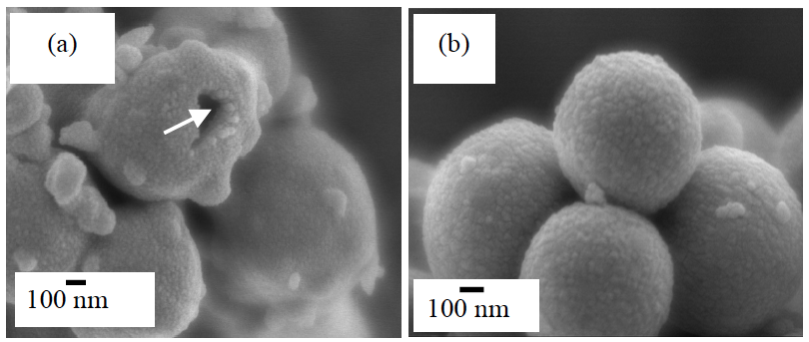

Fig. 2 FESEM images of (a) Ag@TiO₂ and (b) Ag/TiO₂ microspheres.

Further information on the elemental composition of the samples can be provided by EDX analysis. Fig. 4 shows the EDX spectrum of synthesized Ag@TiO₂ while the elemental composition of Ag@TiO₂ sample is summarized in Table 1. The EDX results confirmed the presence of Ti, O and Ag elements in the microspheres. The spectrum (Fig. 5) shows that Ag/TiO₂ microspheres consist of Ti, O and Ag elements with the corresponding percentages given in Table 2. The distribution of Ag in heterostructure was confirmed by the EDX elemental mapping as shown in Fig. 6. The EDX elemental mapping clearly shows the presence of Ag particles on TiO₂, which should correspond to the darker small spots in HRTEM image (Fig. 3(d)).
The amount of Ag in Ag@TiO₂ and Ag/TiO₂ samples was determined by XRF measurement. Table 3 and 4 illustrate Ag content in the prepared samples. Experimental Ag mass % measured by XRF technique is in good agreement with the calculated one, revealing the effectiveness of the current preparation methods.

Table 3 Elemental analysis by XRF for Ag@TiO₂ microspheres.

Component | Mass %

Si  TiO₂  Ti  Ag  Mg  Al | 0.1  65.3  33.3  1.3  0.1  0.1

Evaluation of photocatalytic activity
The photocatalytic activity of Ag modified hollow anatase TiO₂ microspheres in the environment was tested out in the photodegradation of imazalil sulphate and its imazalil sulphate photodegradation efficiency was compared with that of commercial TiO₂. The photodegradation efficiency was calculated using the Eq. (3).

Photodegradation efficiency (%) = (1- C_{t}/C₀) × 100 (3)

Where C₀ is the concentration of the compound before illumination and C_{t} is the concentration of solution after time t. Fig. 12 shows the photodegradation efficiency of imazalil sulphate. The photodegradation efficiency was in the following order: Ag/TiO₂ > hollow anatase TiO₂ > Ag@TiO₂ > commercial anatase TiO₂. The highest efficiency was shown by Ag/TiO₂ photocatalyst. 5 h of irradiation resulted in degradation of 27.9% for imazalil sulphate. From Fig. 12, it can be seen that the presence of Ag nanoparticles on the surface of hollow TiO₂ gave a more efficient photodegradation than the other photocatalysts, which demonstrates the efficiency of Ag nanoparticles in reducing the recombination rate of the electron-hole pair. Even though the prepared photocatalyst contains Ag in the metallic form, it can act as an electron sink (Wang et al., 2013). When the reaction mixture is irradiated by UV, the photoexcited electrons from the valence band of TiO₂ gets captured by the Ag, allowing the generated hole to decompose the pesticides (Chiarello et al., 2008; Wang et al., 2013). Electron migration from the conduction band of TiO₂ to the metallic Ag particles is feasible since the Fermi level of TiO₂ is higher than that of Ag metal (Wang et al., 2013). When the quantity of Ag is little and the photogenerated electrons effectively migrate to Ag, better separation of electrons and holes would be accomplished. The role of Ag is to increase separation of the electron-hole pair, decreasing recombination rate of the electron-hole pair and in turn, enhanced the photocatalytic efficiency of the Ag/TiO₂ photocatalyst.

CONCLUSION

Hollow anatase TiO₂ containing Ag, in the different location, has been successfully synthesized. This was proven by the images obtained using TEM. Apart from that, the existence of Ag was also confirmed by XRF and EDX. DR UV–Vis spectra showed the existence of absorbance peak for Ag at around 404–650 nm. The Ag’s particles size was measured by TEM. The results showed that the size of Ag particles inside the hollow anatase TiO₂ sample was larger (45 nm) than its particles size when it was located outside (9–20 nm).

ACKNOWLEDGEMENT

This work was financially supported by the Universiti Teknologi Malaysia under the Research University Grant and the Ministry of Higher Education Malaysia with reference number XXXXXX.

REFERENCES

Nur, H., Hayati, F., Hamdan, H. 2007. On the location of different titanium sites in Ti-OMS-2 and their catalytic role in oxidation of styrene. Catal. Commun. 8, 2007-2011.
Nur, H., Guan, L. C., Endud, S., Hamdan, H. 2004. Quantitative measurement of a mixture of mesophases cubic MCM-48 and hexagonal MCM-41 by ¹³C CP/MAS NMR. Mater. Lett. 58, 12-13, 1971-1974.

