**FULL PAPER TITLE**

**First Author1, Second Author*2 and Third Author3 (Full Name)**

1, 2 Authors’ Department, Institute, City, COUNTRY.

(E-mail: firstauthorsname@aaaa.bbb, *secondauthorsname@aaaa.bbb)

3 Author’s Department, Institute, City, COUNTRY. (E-mail: thirdauthorsname@aaaa.bbb)

**ABSTRACT**

The abstract should not be more than 200 words each. The abstract should not only indicate the subject and scope of the paper but also summarize the author’s conclusion. Structured abstract must be a brief, comprehensive summary of the contents of the article. It allows readers to survey the contents of an article quickly. An Abstract summarizes the major aspects of a paper. **It should succinctly summarize the purpose of the paper, the application design (for scholarly experience sharing paper) / methods (for scholarly discovery paper) used, the key findings, and conclusions.**

**Key words: Keyword 1, Keyword 2, Keyword 3 (3 (minimum) – 5 (maximum) keywords)**

**INTRODUCTION**

This format is to be used for submissions of extended abstract that will be published in the STLEE 2022 proceeding. We wish to give this proceeding a consistent, high-quality appearance and therefore request that authors follow these simple guidelines. In essence, you should format your paper exactly like this document. The easiest way to do this is simply to download a template from the conference web site and replace the content with your own material. Here, we also share the suggested points as guidelines on the required contents of the paper.

In this section, authors should provide the context and problem background before focusing on one or two aspects of the problem. Authors should address the importance of addressing these problems and can include what other publications say about the problem. The section should finally lead to the intended outcomes or objectives of the paper. Strong references will be helpful in supporting the statement to set the stage for the problem and the specific objectives that will be focused on.

**LITERATURE REVIEW**

In this section, more details about the highlighted problems and what other say about the problems to overcome should be analyzed. The review could be on related concepts, as well as what others have done using the approaches considered to overcome similar problems.  When analyzing activities by others and how they are implemented, education principles that underpin how the instruction or learning activities are designed should be discussed. How others use the approach that was used and the variation in application is good to include. The literature review should also show the gap in knowledge and on implementation aspects in different settings, which can be part of the significance of the paper.

**APPLICATION DESIGN**

This section should explain the design process which are based on established principles, concepts or any other literature (when a suitable principle cannot be found). Authors are suggested to relate the design to the principles and explain on the planning and execution of the activities. The planning in terms of the overall view towards achieving the outcomes, and the detailed activities that support the attainment of outcomes should be described systemically.

Any illustrations or diagrams on the flow or timeline of the design and plan of implementation will be helpful for readers to have an overall picture that can connect their understanding with the detailed description. Appropriate figures can be included and should be referred to in the text. Please ensure that the figures are inserted in the text box provided below (as in Figure 1).

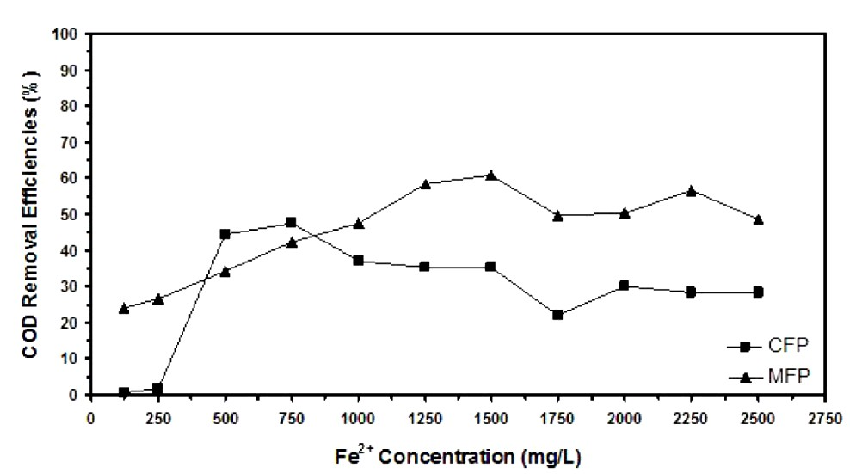

**Figure 1.** Example of figure for the full paper.

**FINDINGS & DISCUSSION**

In this section, authors should elaborate assessment made to see the impact of the intervention in overcoming the problems described earlier. Assessments should measure relevant aspects related to the problem and indicate whether the implemented interventions work. Findings should be supported by relevant evidence. Discussions should provide meaningful interpretations of the findings in relation to the implementation application design. Qualitative feedback or reflections may also be used. Authors are suggested to compare if their findings are in accordance with the principles and findings of others in the literature, whether similar findings were found or something different.

A table should be inserted as in Table 1 and should be referred in the text. Please avoid vertical rules and shading in table cells.

|  |
| --- |
|  |
| Contents of table |
|  |
|  |

**Table 1**. Example of table for the extended abstract

**CONCLUSION**

The conclusion is intended to highlight the key findings and its significance (without overclaiming or exaggerating) in addressing the initial problems. A conclusion is not merely a summary of the main topics covered or a re-statement of your research problem but a synthesis of key points and, if applicable, where you recommend new areas for future research. Authors may discuss if the proposed intervention can be generalized and applied in other settings or fields with justifications on what to be adjusted to get similar outcomes.

**Acknowledgment:** The authors would like to express their appreciation for the support of the sponsors with Project No xxxx.

The full paper should be written in MS Word format in single-spaced in 11-point Times New Roman. Do not indent the text paragraphs. Authors are requested to submit the full paper (**minimum of 4 pages in length and pages should not be numbered**) in electronic form (MS-Word) via Google Form link provided in the registration section. Papers which do not conform to the format may be returned back to the authors for further amendments.

**REFERENCES (Numbered, Vancouver Style)**

**1.** Author. Title. Journal. Year; Volume (Issue): Pages. **(Journal Article)**

2. Author. Title. Conference Name; Date; Conference Location. Place Published: Publisher; Year

Published. **(Conference Papers)**

3. Author. Title. Conference Name; Year of Conference Date; Conference Location. Place Published: Publisher; Year Published. **(Conference Proceedings)**

4. Schwartz, M. Title. Edition. Series editors. Place Published: Publisher; Year Date. Number of Pages.

**(Book)**

5. Author. Title. In: Editor’name, editor. Book Title. Series Title. Volume. Edition. Place Published: Publisher, Year. Pages. **(Book Section)**

6. Author. Title [Thesis Type]. Place Published: University; Year. **(Thesis)**

**APPENDIX (optional)**

Authors may include any relevant appendix/appendices if applicable.